ANC1A EDUCATION COMMITTEE

DANCE INSTITUTE OF WASHINGTON
3400 14th ST., NW
Washington, DC 20010
(202) 371-9656
https://www.danceinstituteofwashington.org

Volunteer Opportunities: Internships and volunteer opportunities are project based and can be subject to renewal after evaluation. https://www.danceinstituteofwashington.org/opportunities
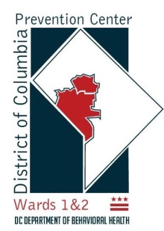
DC PREVENTION CENTER WARDS 1 & 2
1419 Columbia Road, NW
Washington, DC 20010
(202) 660 - 1636
http://www.layc-dc.org/what-we-do/health-wellness/dc-prevention-center-wards/

Volunteer Opportunities: There are opportunities for a variety of interests and availabilities. There are openings vary throughout the year, so please check in often: http://www.layc-dc.org/get-involved/volunteer/

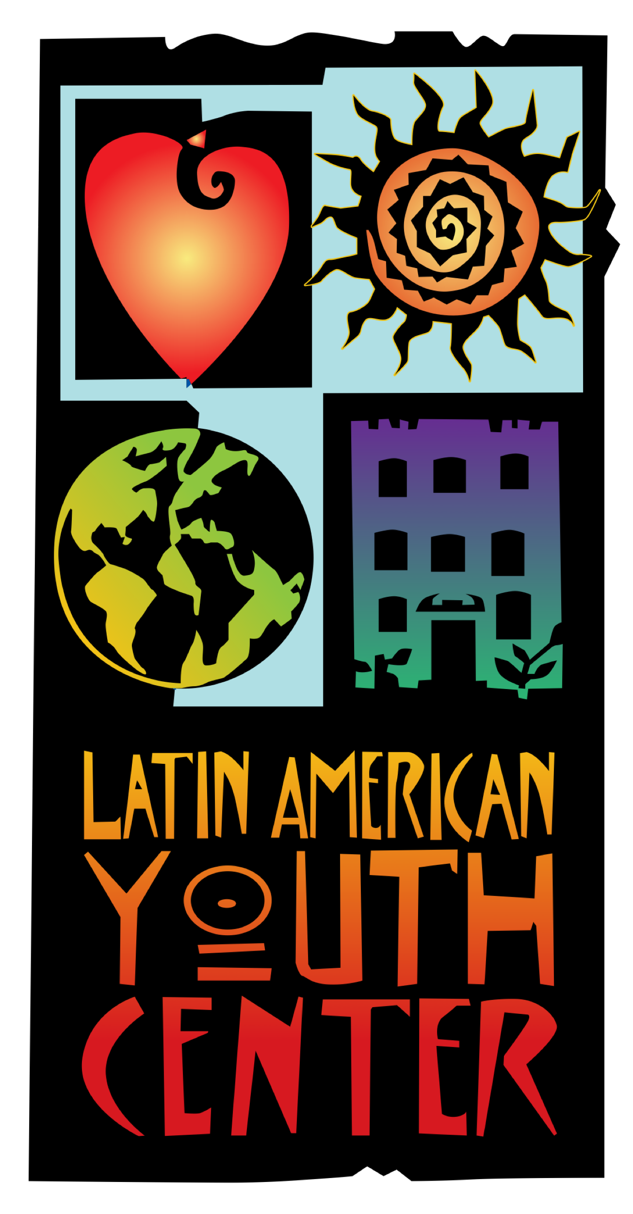
LAYC DC SAFE HOUSING DROP-IN CENTER
3045 15th Street, NW
Washington, DC 20010
(202) 768 - 7801
http://www.layc-dc.org/youth-corner/dc-safe-housing-drop-in-center/

Volunteer Opportunities: The Drop-In Center accepts donations of gently used clothing, donations, hygiene products, new undergarments, and socks or, donate here: https://layc.networkforgood.com/projects/19165-brighter-futures

LAYC RITA BRIGHT FAMILY AND YOUTH CENTER
2500 14TH Street, NW
Washington, DC 20003
(202) 670 - 5949
http://www.layc-dc.org/what-we-do/arts-recreation/rita-bright-family-youth-center/

Volunteer Opportunities: http://www.layc-dc.org/get-involved/volunteer/
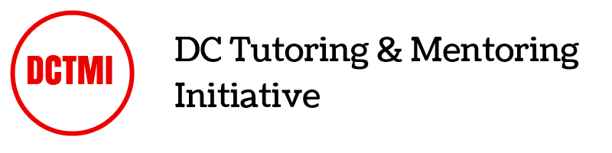
DC TUTOR & MENTORING INITIATIVE
2437 15th Street, NW 1419
Washington, DC 20010
﻿(202) 688 1261
http://www.dctutormentor.org

Volunteer Opportunities: There are a variety of ways to get involved beginning with volunteering to tutor or mentor. There are also partnership opportunities for other organizations and a need to recruit others at work or in your community. http://www.dctutormentor.org/get-involved/

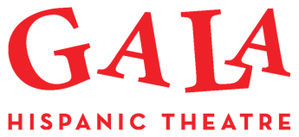
GALA Hispanic Theatre
3333 14th St NW
Washington, DC 20010
(202) 234-7174
http://www.galatheatre.org

Volunteer Opportunities: Join in a variety of opportunities, have fun, and meet other adults interested in the arts. Or, contribute your time and talent to support GALA and GALita presentations. If you would like to sign up GALA’s volunteer opportunities or if you have any questions, please contact info@galatheatre.org, call (202) 234-7174, or register online. http://en.galatheatre.org/2016/05/volunteer.html

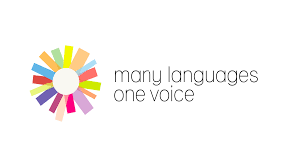
MANY LANGUAGES ONE VOICE
3166 Mt Pleasant Street, NW
Washington, DC 20010
(202) 838 - MLOV (202-838-6568)
http://www.mlovdc.org

Volunteer Opportunities: Many Languages One Voice is seeking volunteers to translate documents, video and audio testimonies of Limited- and Non-English proficient community members. If you have a few hours per month to spare, you can volunteer from home. Email sapna@mlovdc.org to share your translation skills with us!

MLOV is also looking for attorneys who can assist in completing paperwork needed to help release children currently being held immigration camps. Please contact: jairo@mlov.org

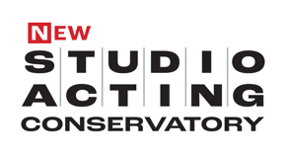
STUDIO ACTING CONSERVETORY
2031 10th Street, NW
Washington, DC. 20001
studioactingconservatory.org

Volunteer Opportunities: Help spread the word - share the work and opportunities being offered.

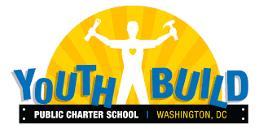
YOUTHBUILD
3220 16th Street, NW
Washington, DC 20010
(202) 319-0141
https://www.youthbuildpcs.org

Volunteer Opportunities: There are many ways to get involved and support YouthBuild PCS. Find opportunities as a tutor, teachers' aides, career coach, or programmatic or specialized volunteer. If you have an interest in volunteering as a tutor: https://www.youthbuildpcs.org/volunteer

YOUTH SERVICE AMERICA
https://ysa.org

Volunteer Opportunities: Support your local schools and organizations in youth-led projects and partnerships. Find out service days and opportunities here: https://leadasap.ysa.org/ideas/

For more information on volunteer opportunities, resources available, and organizations serving youth in our community, please visit our website: http://anc1a.org/committees/education/

TOGETHER WE CAN DO MORE!!

